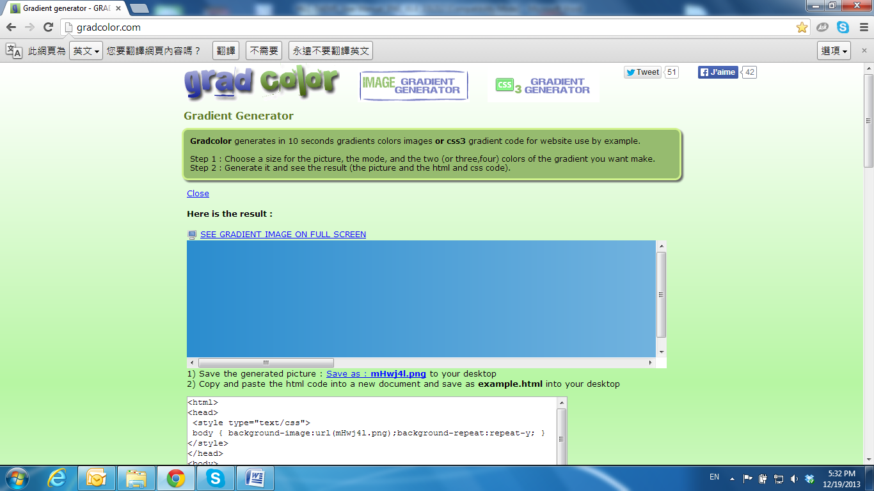

Install ActiveX control

**1. For users of IE 6.0 or above:**

When viewing the camera video for the first time via IE, the browser will ask you to install the **ActiveX** component.

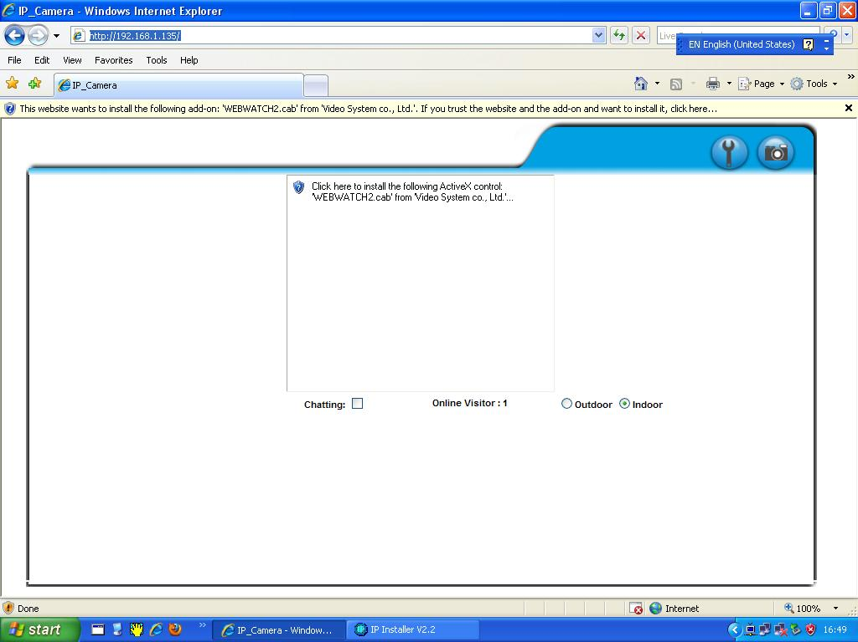

1. If the installation failed, please check the security settings in the IE browser.

1. IE 🡪 Tools 🡪 Internet Options… 🡪 Security Tab 🡪 Custom Level… 🡪 Security Settings 🡪 Download unsigned ActiveX controls🡪 Select **Enable** or **Prompt**.
2. IE 🡪 Tools 🡪 Internet Options… 🡪 Security Tab 🡪 Custom Level… 🡪Initialize and script ActiveX controls not marked as safe 🡪 Select **Enable** or **Prompt**.

|  |  |
| --- | --- |
| **1** | **2** |
| 830-060 | 830-061 |
|  |  |
| **3** | **4** |
| 830-062 | 830-063 |
|  |  |
| **5** | |
| When popup the following dialogue box, click **Yes**.  830-064  2. You can choose another way:  **Go to:** IE→Tools → Internet Options… → Security Tab → Trusted sites → Add the IP address and click **OK**.  In the site list you can key one single IP address or a LAN address. For example, if you add **192.168.21.\***, all the IP address under **21.\*** on the LAN will be regarded as trusted sites.    **2. To Non-IE Web Browser Users**  If you use Firefox or Google chrome to access the IP camera but fails to watch the live video, please follow the steps to install necessary tools:  (The following pictures are based on chrome.)  a. You may see the prompt message as the picture below. Click the link:  **Firstly, please install Microsoft Visual C++ 2010 Redistributable Package (x86).**  noactivex  The link will conduct you to the Microsoft official site where you can download the tools. Please select the language and click **download**.    In the pop-up window, please tick the first and the third file as the picture below. Click **Next** to download both **Microsoft .NET Framework 4 Client Profile (Web Installer)** and **Microsoft Visual C++ 2010 Redistributable Package (x64)**.    After finishing downloading, execute the two files respectively to install them. The windows may ask you to reboot the PC when the installation is finished.    b. Then, click the second link **Please click here to download the installation program which does not support IE browser** to download Setup ActiveX.  After finishing downloading, execute the files to install **ActiveX**. Then restart the browser.  c. If you execute the steps above but still cannot see live video normally, please try the following solution:  Search for the file **np_hoem_x.dll** in your system disk. For Windows XP users, please go to **Start** → **Search** → Search for **All files and folders** and key-in **np_hoem_x.dll**. For Windows 7 users, please use the search bar on the top-right of the Windows Explorer.    Delete all the files named **np_hoem_x.dll**. They're the **ActiveX** control tools installed in your computer, but the old version of **ActiveX** might not be compatible with the new version of the browser. Therefore, they need to be deleted in order to install the latest **ActiveX** control.    Start your web browser, and repeat the step 2-b: **Download the installation program which does not support IE browser** to download and install **ActiveX**.  noactivex | |